ARM Microservices - IIS Hosting Guide – BATCH Installer

Overview
This document explains how to use One click Batch configuration for IIS hosting for ARM microservices:
Root Website: Default Web Site (for reference. Can create separate site as per implementation need)
Root Application Name: ARM_APP (This name is just for reference)
Root Physical Path: ARM_APP FOLDER PATH

Folder Structure
The main ARM_APP folder will have all microservice API folders as below:
ARM_APP FOLDER PATH
│
├── ARMNotificationHub
├── ARM_APIs
├── AxAuth
├── AxList
├── AxStructUtils
├── AxTstructData
└── AxUtils
└── AxPlugins (Optional. Use this site incase of plugin APIs)
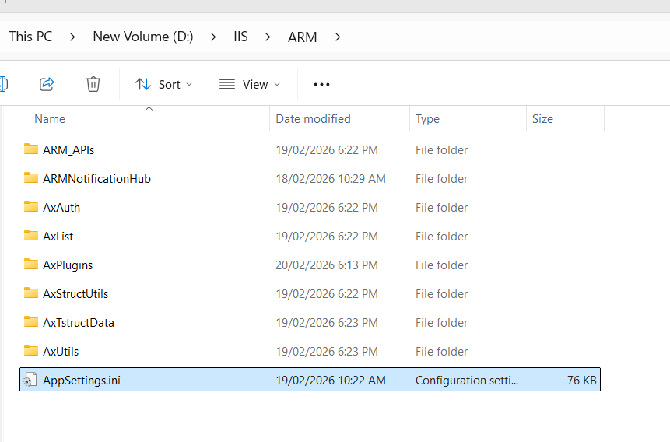

1. Prerequisites
- IIS must be installed
- ASP.NET Core Hosting Bundle (8.0), ASPNet core SDK.
- Ensure folder ARM_APP FOLDER PATH exists
- Ensure IIS_IUSRS has proper permissions
- All installations as per previous version of ARM.

2. Editing the batch file:
- Extract the ARM_Microservices_OneClick_IIS_Configure.bat from the ARM_Microservices_OneClick_IIS_Configure.rar file
- Edit in notepad or any other text editor
- Set your main sitename, Root ARM app name, Folder path in following variables.
set SITE_NAME=Default Web Site
set ROOT_APP_NAME=ARM_Site3
set ROOT_PATH=D:\IIS\ARM

3. Running the batch file:
- Select the batch file.
- Right click and do “Run as Administrator”
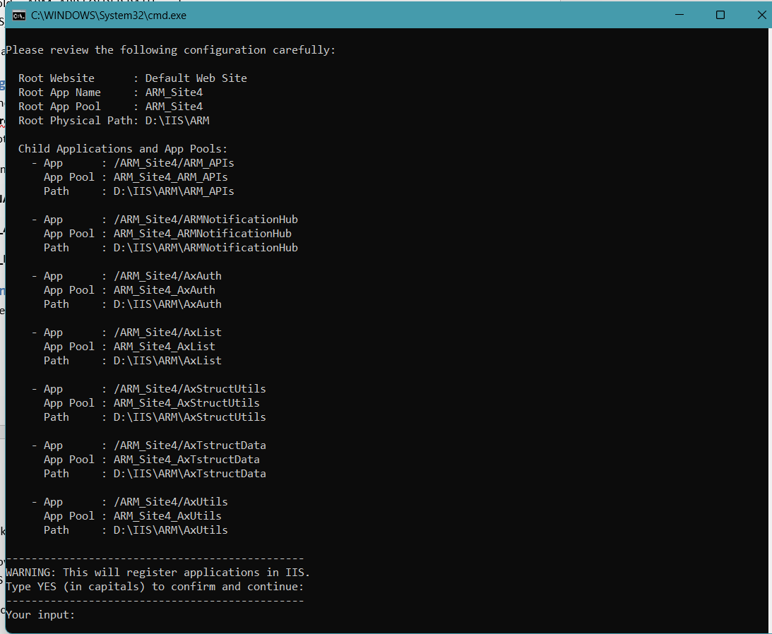
- It will show the list to be installed and will ask you to type YES (in caps) to proceed.
- Enter YES
- After successful configuration, will get message like “ARM Microservices IIS Hosting Setup Completed Successfully”

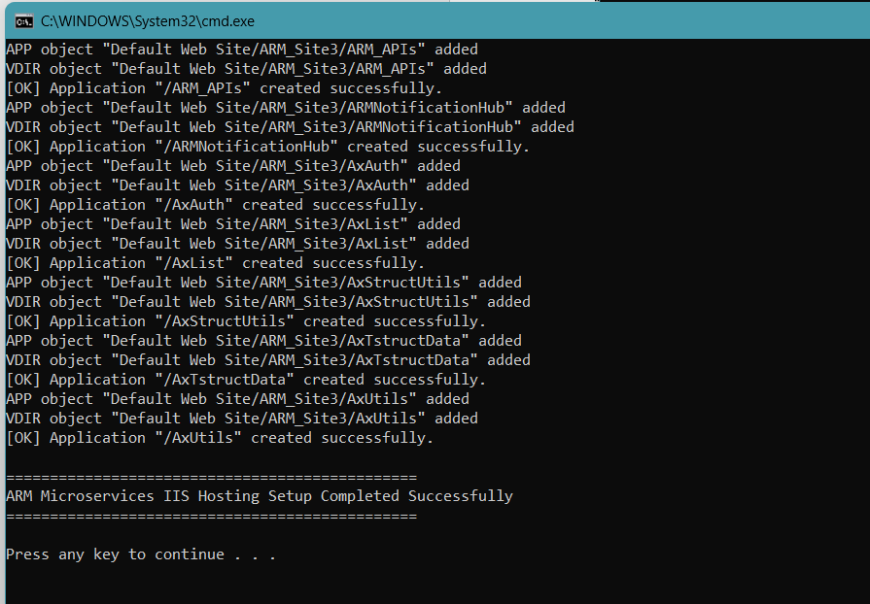

5. Permissions
Grant the following permissions on ARM_APP FOLDER PATH:
IIS_IUSRS, IUSR → Full access

6. Restart IIS
Run command: iisreset

7. Testing URLs for ARM Microservices
Run this URLs in postman (HTTP GET)/browser to check whether the microservice URLs are running fine or not.

<Your ARM URL>/ARM_APIs/api/v1/ARMAppStatus

<Your ARM URL>/ARMNotificationHub/api/v1/ARMAppStatus

<Your ARM URL>/AxAuth/api/v1/AppStatus

<Your ARM URL>/AxList/api/v1/AppStatus

<Your ARM URL>/AxUtils/api/v1/AppStatus

<Your ARM URL>/AxStructUtils/api/v1/AppStatus

<Your ARM URL>/AxTstructData/api/v1/AppStatus

All above URLS will return “Application running successfully” in JSON format.

Appsettings.ini configuration:
- Latest Appsettings.ini should be placed/replaced in the main root ARM_APP folder. It should not be placed inside the microservice application folders.
- IISREST/Application pool recycle (for all microservice applications) should be done in case of Appsettings.ini change.

Important Note:
The ARM Microservice application app names should not be changed and it should be one of the following:
ARMNotificationHub
ARM_APIs
AxAuth
AxList
AxStructUtils
AxTstructData
AxUtils
AxPlugins (Optional. Use this site incase of plugin APIs)

